

**NATIONAL ECONOMIC CONSULTATIVE FORUM**

**MONTHLY ECONOMIC BULLETIN**

**NOVEMBER 2024**

# Executive Summary

This bulletin focuses on economic developments for the month ending 29 November 2024 that include, world economic developments, international commodity prices, Zimbabwe Gross Domestic Product (GDP) growth updates, merchandise trade developments, exchange rate developments, inflation developments, monetary developments and stock market developments.

Global economic growth remained resilient in 2024, with a projected expansion of 3.2%, according to the IMF and OECD Economic Outlook 2024. Advanced economies, led by the United States, demonstrated solid growth supported by wage-driven private consumption. Emerging markets like China, India, and Indonesia exhibited robust activity, though China's demand remained subdued. In 2025 and 2026, global growth is forecasted to moderate to 3.3%, influenced by tighter monetary policies and declining inflation. Global inflation is set to decelerate further, from 6.7% in 2023 to 5.8% in 2024 and 4.3% in 2025, amid lower commodity prices and restrained demand.

Commodity prices showed mixed trends in November 2024. Natural gas, nickel, cotton, soybeans, and corn recorded gains, while crude oil, aluminum, copper, gold, and wheat experienced declines. Crude oil prices fell by 0.59% month-on-month (MoM) due to weaker global demand and anticipated supply increases. Zimbabwe could leverage declining oil prices to enhance production capacity.

Meanwhile, the Zimbabwean economy is expected to grow by 2% in 2024, with agriculture showing better-than-expected performance despite contraction in mining and manufacturing. Looking ahead, growth is projected to accelerate to 6% in 2025, driven by improved agriculture, increased electricity generation, and stable economic conditions.

Zimbabwe’s merchandise trade totalled USD 1.36 billion in September 2024, a 12.3% decline from August, attributed to lower exports and imports. The trade deficit widened to USD 207.6 million. Exports, primarily of gold, PMGs, and ferrochromium, fell by 14.7% MoM. Imports were dominated by diesel and maize, with South Africa and China as key trading partners.

The ZWG appreciated against regional currencies like the ZAR but depreciated by 2.28% against the USD in November. Parallel market premiums ranged between 38% and 58%, reflecting persistent divergence between official and parallel exchange rates. Fiscal discipline measures, such as Treasury Circular No. 7, were instrumental in stabilizing the official exchange rate.

ZWG month-on-month inflation decelerated significantly from 37.2% in October to 11.7% in November, driven by tighter monetary policies. Weighted inflation also dropped from 7.3% to 2.2%, attributed to declining prices for food and energy.

Broad money supply surged by 61.4% to ZWG 75.01 billion in September 2024, primarily due to exchange rate adjustments. Meanwhile, lending rates for both local and foreign currencies increased, raising borrowing costs and potentially dampening investment.

The Zimbabwe Stock Exchange (ZSE) was dominated by bearish trends in November, with all share index and market capitalization declining by 8.31% and 8.58%, respectively. The Victoria Falls Stock Exchange (VFEX) also faced headwinds, with market capitalization falling by 0.98%, influenced by subdued investor interest and competition from USD-denominated assets.

This analysis underscores the interplay of global trends and domestic policies in shaping Zimbabwe's economic trajectory. Maintaining fiscal and monetary discipline remains key to fostering sustainable growth, stabilizing inflation, and enhancing investor confidence.

**Table of Contents**

Executive Summary i

1.0 World Economic Developments 1

1.1 World Output 1

1.2 Global Inflation Developments 1

2.0 International Commodity Prices 1

3.0 Zimbabwe GDP Growth Update 2

4.0 Merchandise Trade Developments 3

5.0 Exchange Rate Developments 4

5.1 ZWG Exchange Rate Developments 4

5.2 Parallel Market Developments 4

5.3 Cross Rate Developments 5

6.0 Inflation Developments 6

7.0 Monetary Developments 7

7.1 Money Supply 7

7.2 Interest Rates 8

8.0 Stock Market Developments 9

8.1 Zimbabwe Stock Exchange (ZSE) 9

8.2 Victoria Falls Stock Exchange (VFEX) 9

9.0 Recommendations 10

10.0 References 11

**List of Tables**

Table 1: Commodity Price Movements – Month Ending 29 November 2024 2

Table 2: ZWG Exchange Rate Movements-Month Ending 29 November 2024 4

Table 3: USD Exchange Rate Movements–Month Ended 29 November 2024 5

Table 4: Monthly Inflation for November 2024 7

Table 5: Interest Rates as of 15 November 2024 8

Table 6: Zimbabwe Stock Exchange Movements 9

Table 7: Victoria Falls Stock Exchange Movements 9

**List of Figures**

Figure 1: Global Economic Growth Developments 1

Figure 2: Zimbabwe Economic Growth Prospects 3

Figure 3: Merchandise Trade Developments 4

Figure 4: Parallel Market Developments - November 2024 5

Figure 5: Month-on-Month ZWG Inflation Outturn 6

Figure 6: Month-on-Month Weighted Inflation Outturn 6

Figure 7: Broad Money (M3) Supply 8

# 1.0 World Economic Developments

## **1.1 World Output**

1.1.1 According to OECD Economic Outlook (2024) and the International Monetary Fund (IMF) World Economic Outlook (WEO) October 2024 Update, global economy has remained resilient in 2024 with a growth projection of 3.2%. In the advanced economies, growth in the United States remain solid, with private consumption underpinned by wage gains and relatively robust in Netherlands and Spain. In emerging markets, China growth held up in third quarter, with industrial growth due to exports strengthening but demand remained soft while India and Indonesia expansion being driven by domestic demand. In the European countries, activity remain more modest in manufacturing than in service sector.

1.1.2 Looking ahead, the OECD Economic Outlook (2024) projects a 3.3% global growth in 2025 and 2026 due to legged impact of monetary tightening, declining global inflation, see Figure 1.

Figure 1: Global Economic Growth Developments

*Source: IMF, WEO October 2024 Update and OECD Economic Outlook (2024)*

## **1.2 Global Inflation Developments**

1.2.1 Global inflation remains projected to steadily decelerate from 6.7% in 2023 to 5.8% in 2024 and to 4.3% in 2025 due to decreasing commodity prices especially oil and tight monetary policies adopted by many central banks.

# 2.0 International Commodity Prices

2.1 The month-on-month prices for natural gas, nickel, cotton, soybeans and corn increased while crude oil, aluminum, copper, gold and wheat prices retreated, see Table 1.

2.2 On a month-on-month basis, crude oil, aluminum, copper, gold and wheat prices declined by 0.59%, 0,91%, 5.4%, 3.24% and 6.7% respectively. The gainers are natural gas, nickel, cotton, soybeans, and corn with 23.2%, 1.76%, 1.95%, 0.71% and 3.47% respectively.

2.3 Natural gas, aluminum, copper and gold prices gained on both YtD and YoY basis while crude oil, nickel, cotton, soybeans, corn and wheat prices retreated on both YtD and YoY basis.

2.4 According to RBZ (2024), crude oil prices retreated due to persistent concerns over weakening global demand and expectations of increased supply from Libya and the broader OPEC+ group. The price trend for crude oil (brent) if maintained, indicates that Zimbabwe is likely to experience reduction in fuel prices going forward.

Table 1: Commodity Price Movements – Month Ending 29 November 2024

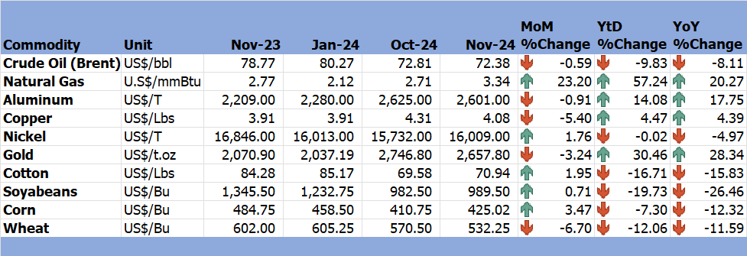

*Source: Trading Economics (2024)*

# 3.0 Zimbabwe GDP Growth Update

3.1 The economic growth is estimated at 2% in 2024 (see Figure 2). According to the MoFED&IP (2024), 2024 agriculture sector output projection was revised from -21% to -15% on account of better than anticipated output on wheat and dairy, however the revision was offset by lower mining and manufacturing performance.

3.2 Looking ahead, the economy is projected to grow by 6% in 2025 due to improvements in agriculture and electricity generation driven by anticipated La-Nina phenomenon, growth in information technology, mining stable exchange rate and low inflation, tight fiscal and monetary policies. Beyond 2025, economic growth is projected to remain steady at 5% driven by private consumption and investments.

Figure 2: Zimbabwe Economic Growth Prospects

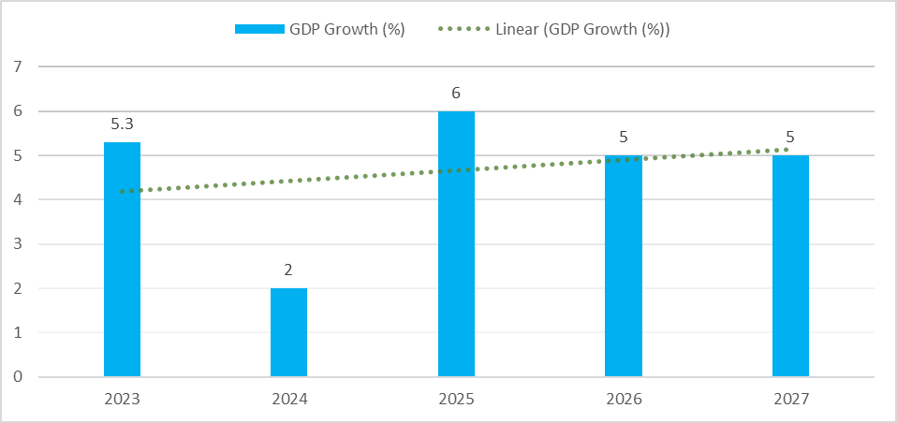

*Source: MoFED&IP (2024)*

# 4.0 Merchandise Trade Developments

4.1 Zimbabwe National Statistics Agency (ZimStat) had not published the merchandise trade data for November 2024 by the time of compiling this report, thus the analysis is based on September 2024 data.

4.2 Total merchandise trade amounted to USD1357.5 million in September 2024, a 12.3% decrease from USD1547.3 million in August 2024 due to a reduction in both exports and imports. On YoY, merchandise trade retreated by 6.5% down from USD1451.7 million in September 2023 (RBZ September 2024 Monthly Review).

4.1 The trade deficit worsened in September 2024 from USD198.8 million to USD207.6 million in August 2024 (see Figure 3). Exports were USD575 million (mainly gold, PMGs and Ferrochromium) mostly to United Arab Emirates, South Africa and China, a 14.7% m-o-m decline due to a decline in export of gold and PMGs and a 15.2% YoY decline. Import bill amounted to USD782.6 million in September 2024, a 10.4% down from USD973.2 million in August 202, slightly higher than USD773.6 million in September 2023. Imports were dominated by diesel, maize, steam and other vapor turbine parts and petrol mainly from South Africa, China, Bahamas and Singapore.

Figure 3: Merchandise Trade Developments

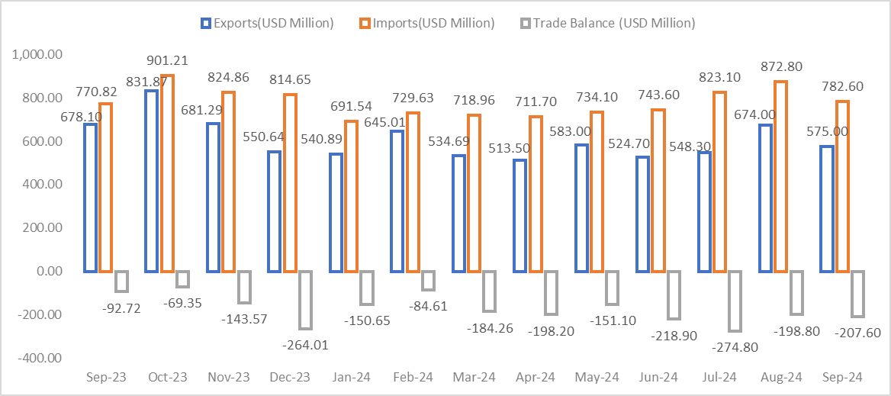

*Source: RBZ (2024)*

# 5.0 Exchange Rate Developments

## **5.1 ZWG Exchange Rate Developments**

5.1.1 The ZWG gained some momentum during the month under review, mainly due to stringent measures to contain expenditure for November and December 2024 contained in Treasury Circular No. 7 of 2024. On a month-on-month basis, the ZWG gained against the GBP, EUR and ZAR by 2.93%, 3.18% and 3.24% respectively, while lost 2.28% against the USD as shown in Table 2. However, the ZWG lost value against all major currencies on a year-to-date and year-on-year basis.

Table 2: ZWG Exchange Rate Movements-Month Ending 29 November 2024

*Source: RBZ (2024)*

5.1.2 Government fiscal discipline remains critical in strengthening and stabilizing the ZWG as well as promoting economic growth and development in Zimbabwe.

## **5.2 Parallel Market Developments**

5.2.1 During the period under review, parallel market remained high and official exchange rate decelerated from around USD/ZWG28.68 and stabilized at around USD/ZWG25.50 with a parallel market premium ranging from around 38% to 58% (see Figure 4). Parallel market premium remains high discouraging the convergence of the two exchange rates, this points that there is punitive exchange rate policy.

Figure 4: Parallel Market Developments - November 2024

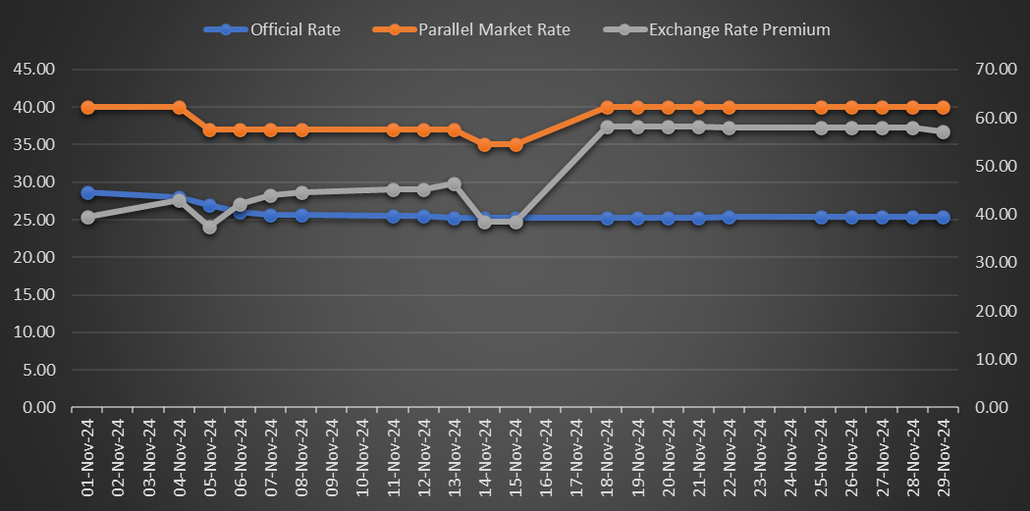

*Source: RBZ and Harare Streets (2024)*

## **5.3 Cross Rate Developments**

5.3.1 On a month-on-month, the USD gained by 1.93%, 2.65% and 2.14% against the GBP, EUR and ZAR respectively, see Table 3. The USD also gained against the EUR on YtD and YoY basis, however, lost value against the GBP and ZAR on both YtD and YoY basis.

Table 3: USD Exchange Rate Movements–Month Ended 29 November 2024

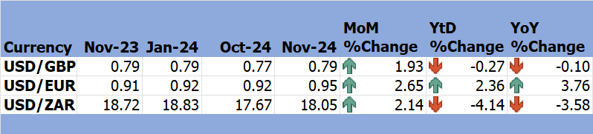

*Source: RBZ (2024)*

5.3.2 The appreciation of USD against other major currencies discourages the country’s exports to its major trading partner, South Africa.

# 6.0 Inflation Developments

6.1 In November 2024, month-on-month ZWG inflation declined from 37.2% in October 2024 to 11.7% in November 2024, see Figure 5. The ZWG m-o-m inflation declined for the first time since the introduction of the ZWG, due to stability surrounding the ZWG due to tight monetary policy stance.

Figure 5: Month-on-Month ZWG Inflation Outturn

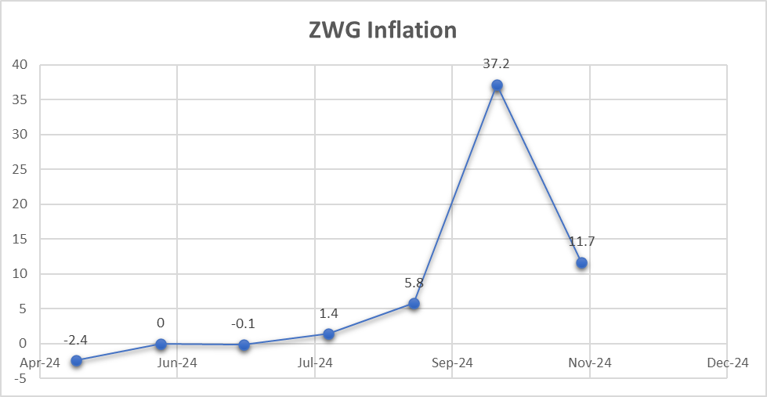

*Source: ZimStat (2024)*

6.2 MoM weighted inflation also dropped from 7.3% in October 2024 to 2.2% in November 2024 (see Figure 6). A fall in weighted inflation was attributed to a decline in ZWG inflation.

Figure 6: Month-on-Month Weighted Inflation Outturn

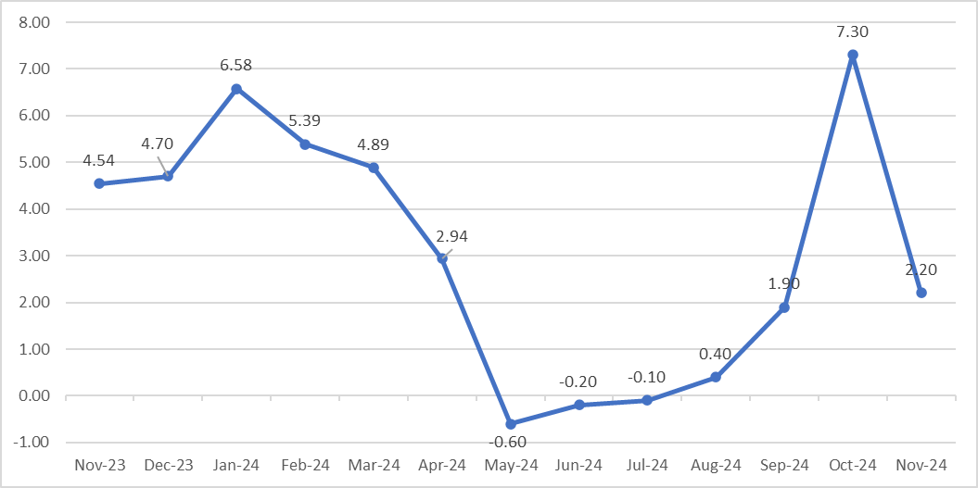

*Source: ZimStat (2024)*

6.3 Food and non-alcoholic drinks, as well as housing, water, electricity, gas, and other fuels, continue to be the largest drivers to both weighted and ZWG inflation in November 2024 (see Table 4).

Table 4: Monthly Inflation for November 2024

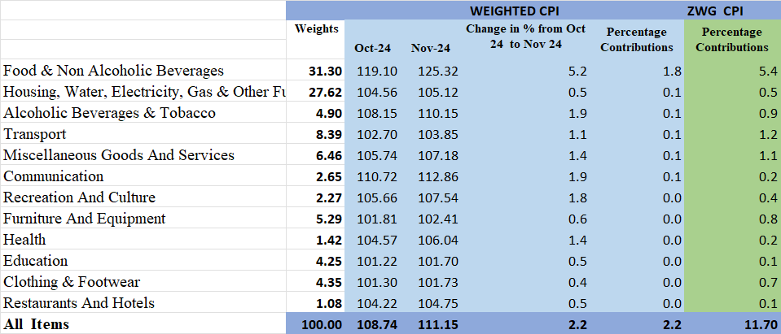

*Source: ZimStat (2024)*

# Monetary Developments

## **7.1 Money Supply**

7.1.1 By the time of compiling this report, November 2024 money supply statistics had not been published thus analysis in based on September 2024 data.

7.1.2 In September 2024, broad money stock stood at ZWG75.007 billion, a 61.4%% increase from ZWG46.47 billion in August 2024 as shown in Figure 7 (RBZ August 2024 Monthly Economic Review). The increase in broad money largely reflected valuation changes of foreign currency deposits related to exchange rate depreciation. The money stock comprised of foreign currency deposits of 82.59%, local currency deposits of 17.30% and local currency in circulation 0.11%.

Figure 7: Broad Money (M3) Supply

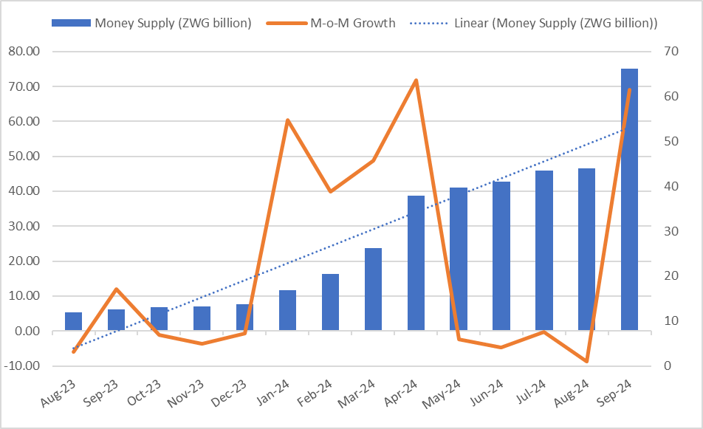

*Source: RBZ (2024)*

## **7.2 Interest Rates**

7.1.1 As of 15 November 2024, the average commercial bank deposit rate for savings on foreign currency was revised by raising a minimum to 1.38% and lowering a maximum to 1.50%. Also, the weighted lending rate on foreign currency for individuals was raised to a minimum 12.85% and maximum of 17.16%, while for corporates, it was revised to 10.65% minimum and a maximum of 14.89%. Weighted lending rates on local currency was revised upwards, to 37.97% minimum and 43.47% maximum while for individuals it was raised to 33.01% minimum and 38.83% maximum for corporates (see Table 5).

Table 5: Interest Rates as of 15 November 2024

|  |  |  |  |  |  |
| --- | --- | --- | --- | --- | --- |
| **Classification** | | **Minimum (%)** | | **Maximum (%)** | |
|  | | **11/10/24** | **15/11/24** | **11/10/24** | **15/11/24** |
| Average Commercial Bank Deposit Rates | Local Currency | 3.75 | 3.75 | 3.88 | 3.88 |
| Foreign Currency | 1.22 | 1.38 | 1.86 | 1.50 |
| Commercial Banks Weighted Lending Rates (Forex) | Individuals | 10.85 | 12.85 | 14.93 | 17.16 |
| Corporates | 9.57 | 10.65 | 15.09 | 14.89 |
| Commercial Banks Weighted Lending Rates (ZWG) | Individuals | 24.31 | 37.97 | 30.45 | 43.47 |
| Corporates | 23.99 | 33.01 | 32.78 | 38.83 |

*Source: RBZ (2024)*

7.1.2 Bank deposit rate was revised downwards, and weighted lending rate was raised for both foreign and local currencies. This revision discourages savings and makes borrowing expensive hence reduced investment retarding economic growth.

# 8.0 Stock Market Developments

## **8.1 Zimbabwe Stock Exchange (ZSE)**

8.1.1 During the month other review, the ZSE was dominated by bearish sentiments. All share index, top 10 index, value traded, and market capitalization fell by 8.31%, 11.95%, 94.34% and 8.58% respectively, see table 6. This downturn was primarily influenced by loses in 12 counters including EcoCash, CBZ and Delta.

8.1.2 On year-to-date and year-on-year, all selected indices gained except value traded which dropped by 56.42%.

Table 6: Zimbabwe Stock Exchange Movements

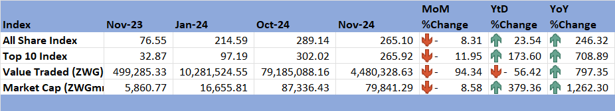

*Source: ZSE (2024)*

## **8.2 Victoria Falls Stock Exchange (VFEX)**

8.2.1 The VFEX faced headwinds in November 2024, with all share index dropping by 0.48% and market capitalization falling by 0.98%. According to The Herald (2024), the bearish trend was driven by seven counters which closed the month at negative territory, announcement of National Foods voluntary delisting, limited foreign investor participation and competition from USD-denominated assets. Value traded gained by 704.8%, see Table 7.

8.2.2 On a YtD basis, all share index, value traded, and market capitalization retreated yet grew on a year-on-year basis as shown on table 7.

Table 7: Victoria Falls Stock Exchange Movements

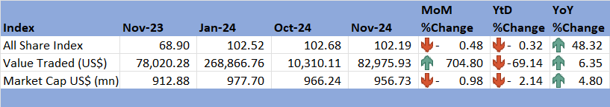

*Source: VFEX (2024)*

# 9.0 Recommendations

9.1 The following recommendations are being proposed:

**9.1.1 Diversify the Economy:** The government should diversify the economy by promoting other sectors such as manufacturing, tourism and services rather than depending on traditional agriculture and mining sector.

**9.1.2 Maintain Fiscal Discipline:** Government should maintain fiscal discipline to avoid overheating the economy and ensure sustainable growth.

**9.1.3 Promote Investment in Infrastructure and Trade:** Investment in infrastructure such as railways and energy can help improve productivity and competitiveness. Investment can also be promoted through promotion of private sector development. The government should also promote trade by providing incentives for exporters, reducing barriers and increasing access to international markets.

**9.1.4 Maintain Tight Monetary Policy:** The Reserve Bank should maintain tight monetary policy to control inflation and stabilise the exchange rate.

* + 1. **Interest Rate Policy:** Lending rates on ZWG are prohibitive while deposit rates on ZWG are discouraging therefore, the Reserve Bank should review interest rates to promote deposits and lending in local currency thus, promoting the use, confidence and stability of the local currency.

**9.1.6 Broad Money Supply Management:** Broad money supply grew by 61.4% in November 2024, which calls for the Reserve Bank to intervene and the maintain growth in money supply aligned with productive sector needs to avoid fuelling inflation.

**9.1.7 Promote Export-Oriented Growth:** There is need to improve production (taking advantage of falling oil prices) in sectors that contribute to exports such as mining (especially gold, PMGs and Ferrochromium) and agriculture to increase export earnings. Diversification of export destination is also critical to in absorbing the risk associated with reliance on traditional markets such as China and Bahamas.

**9.1.8 Stock Market Development:** There is need improve corporate governance by promoting transparency, accountability and disclosure. ZSE and VFEX should promote investor confidence by providing a stable and predictable investment environment.

# 10.0 References

IMF. (2024). *World Economic Outlook, October 2024; Global prospects and Policies: Chapter 1.* International Monetary Fund.

MoFED&IP. (2024). *2025 National Bugdet Statement.* Ministry of Finance, Economic Development and Investment Promotion.

OECD. (2024). *OECD Economic Outlook, Vol 2024 Issue 2: Preliminary Version.* Paris: OECD Publishing.

RBZ. (2024). *Exchange Rates*. Retrieved from Reserve Bank of Zimbabwe: https://www.rbz.co.zw/index.php/research/markets/exchange-rates

Reserve Bank of Zimbabwe. (2024). *Monthly Economic Review: September 2024.* RBZ.

Reserve Bank of Zimbabwe. (2024). *Weekely Economic Highlights, 15 November 2024, Vol 26 No 46.* Reserve Bank of Zimbabwe.

The Herald. (2024, December 2). Retrieved from The Herald: https://www.herald.co.zw/zse-slips-275pc-amid-dwindling-turnover-vfex-also-down-403pc/

Trading Economics. (2024). *Commodities*. Retrieved from Trading Economics: https://tradingeconomics.com/commodity/crude-oil

VFEX. (2024). *Main Dashboard*. Retrieved from Victoria Falls Stock Exchange: https://www.vfex.exchange/

ZimStat. (2024). *Inflation Rates*. Retrieved from Zimbabwe Statistics Agency: https://www.zimstat.co.zw/

ZSE. (2024). *Main Dashboard*. Retrieved from Zimbabwe Stock Exchange: https://www.zse.co.zw/

**NECF Secretariat, 2024**